LAB EXPERIMENT RECORD

SET 15: Product Sales Analysis

Department | AIML
Course Code / Course Name | DSA0601 / Data Handling and Visualization
Experiment | Data Visualization using R
Name | KURUBA VANNUR SWAMY
Register Number | 192424085
Date | 08 october 2026
Day | thursday

Aim
To analyze and visualize monthly product sales data using grouped bar charts, stacked area charts, tables, and an interactive dashboard in RStudio.

Dataset

Product ID | Product Name | January | February | March
1 | Product A | 2000 | 2200 | 2400
2 | Product B | 1500 | 1800 | 1600
3 | Product C | 1200 | 1400 | 1100

PROGRAM 1: Grouped Bar Chart
To compare the first-quarter monthly sales of each product using a grouped bar chart
# # Set 15 Q1 - Grouped Bar Chart sales_data <- rbind(
c(2000, 2200, 2400),
c(1500, 1800, 1600),
c(1200, 1400, 1100)
)
colnames(sales_data) <- c( "January",
"February", "March"
)
rownames(sales_data) <- c( "Product A",
"Product B", "Product C"
)

barplot( sales_data, beside = TRUE,
main = "First Quarter Product Sales", xlab = "Product",
ylab = "Sales",
col = c("lightblue", "lightgreen", "orange"), legend.text = TRUE
) col = c("lightblue", "lightgreen", "orange")
)
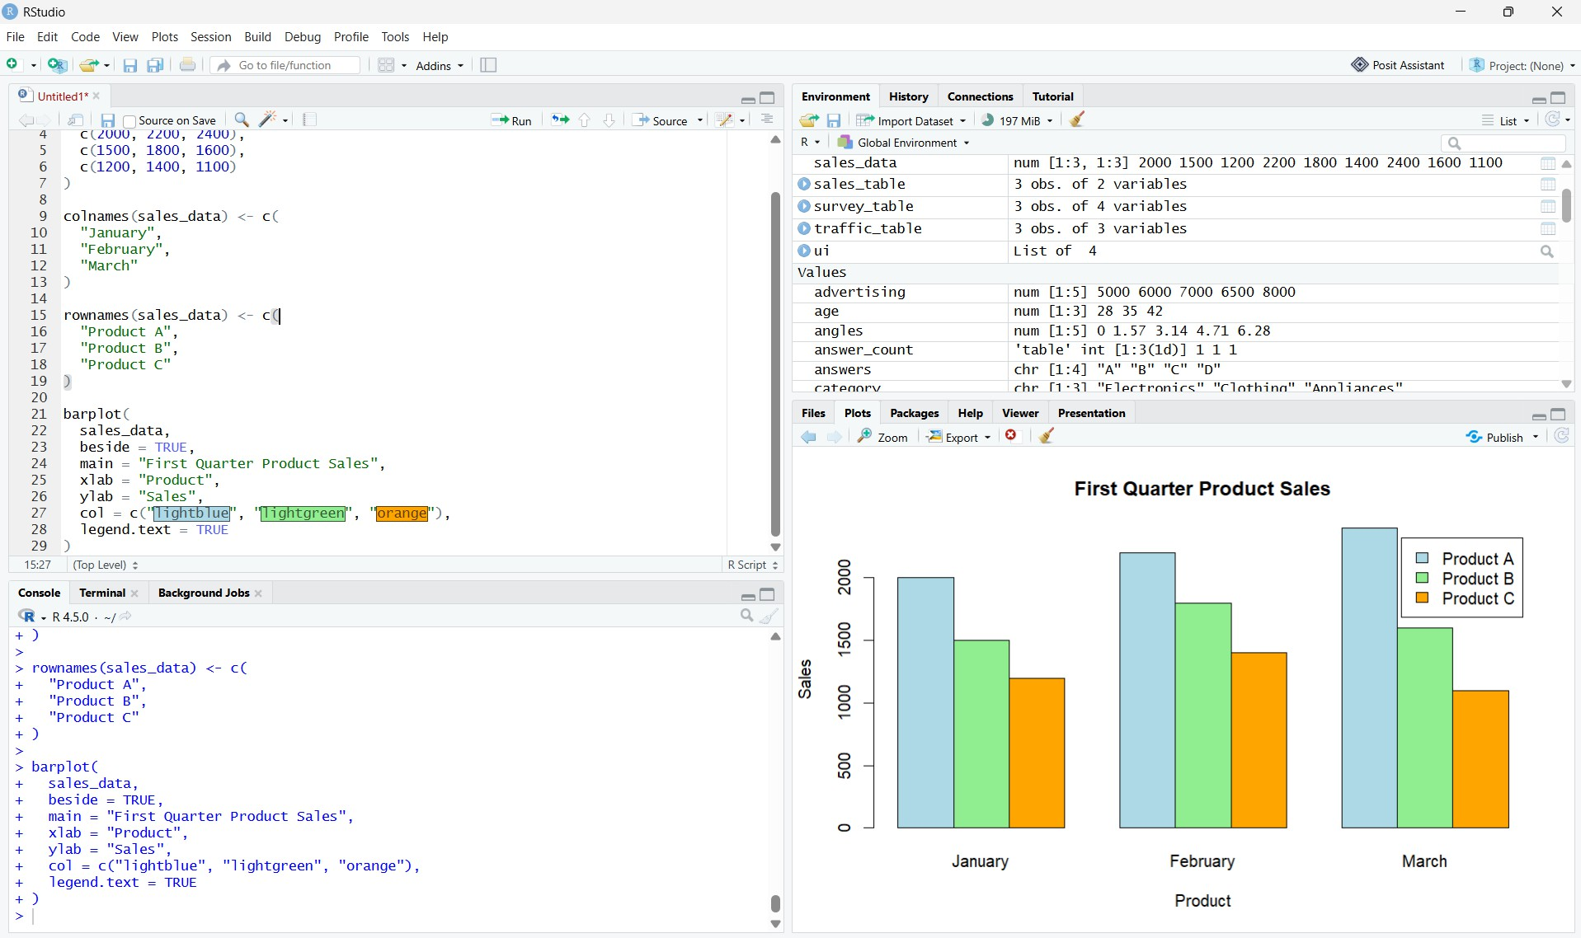

Observation:
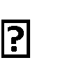
Product A has the highest sales in all three months. Product B has medium sales.
Product C has the lowest sales.

PROGRAM 2: Stacked Area Chart
To represent the overall sales trend of all products over January, February and March

# # Set 15 Q2 - Stacked Area Chart

month <- 1:3

product_a <- c(2000, 2200, 2400)
product_b <- c(1500, 1800, 1600)
product_c <- c(1200, 1400, 1100)
total_a <- product_a
total_b <- product_a + product_b
total_c <- product_a + product_b + product_c
plot(
month,
total_c,
type = "n",
xaxt = "n",
main = "Stacked Product Sales Trend",
xlab = "Month",
ylab = "Sales"
)
axis(
1,
at = 1:3,
labels = c("January", "February", "March")
)
polygon(
c(month, rev(month)),
c(rep(0, 3), rev(total_a)),
col = "lightblue"
)
polygon(
c(month, rev(month)),
c(total_a, rev(total_b)),

col = "lightgreen"
)
polygon(
c(month, rev(month)), c(total_b, rev(total_c)), col = "orange"
)
legend( "topleft", legend = c(
"Product A", "Product B", "Product C"
),
fill = c( "lightblue", "lightgreen", "orange"
)
)

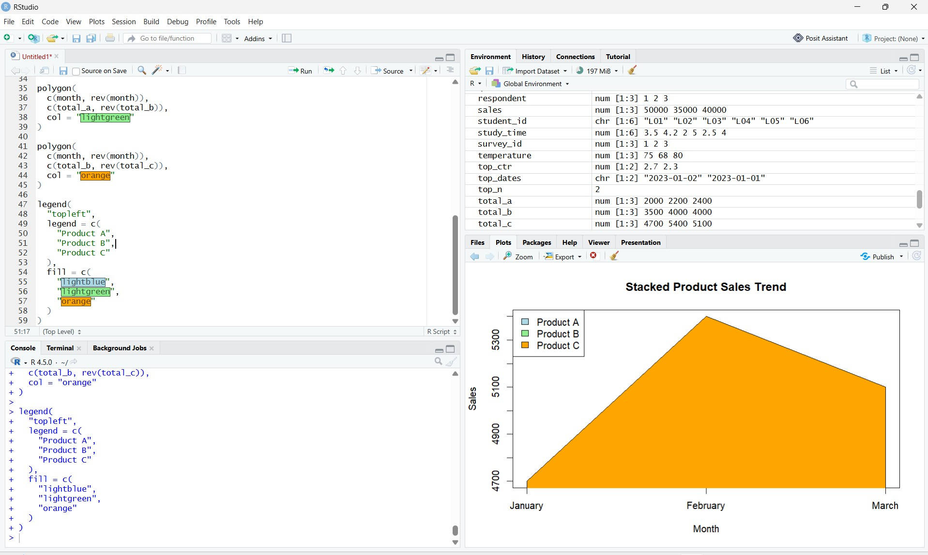

Observation:
TThe total sales are:
- January = 4700
- February = 5400
- March = 5100
Overall sales increase from January to February and slightly decrease in March.

PROGRAM 3: Monthly Sales Table
To display the monthly sales data for each product in tabular form
# Set 15 Q3 - Monthly Sales Table product_id <- c(1, 2, 3) product_name <- c(
"Product A", "Product B", "Product C"
)
january <- c(2000, 1500, 1200)

february <- c(2200, 1800, 1400)
march <- c(2400, 1600, 1100)
sales_table <- data.frame( Product_ID = product_id, Product_Name = product_name, January_Sales = january, February_Sales = february, March_Sales = march
)
sales_table
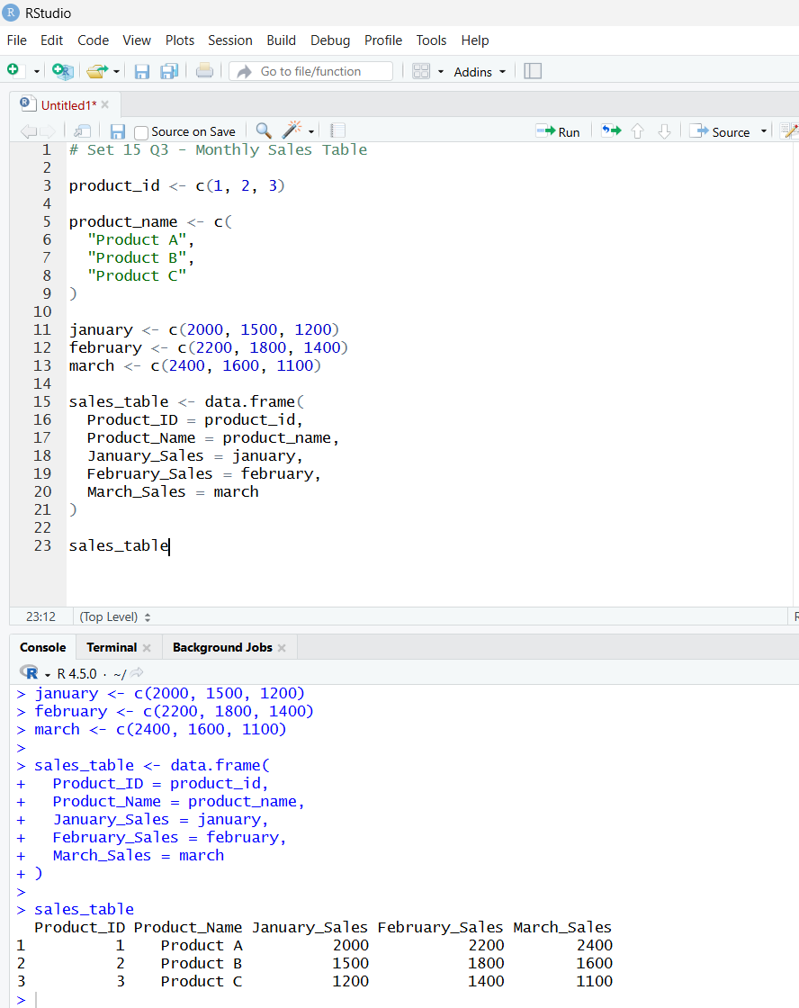

Observation
The monthly sales data of all products was successfully displayed in a table.

PROGRAM 4: Product Sales Dashboard

library(shiny)

product <- c(
"Product A",
"Product B",
"Product C"
)

january <- c(2000, 1500, 1200)
february <- c(2200, 1800, 1400)
march <- c(2400, 1600, 1100)

ui <- fluidPage(

titlePanel("Monthly Product Sales Dashboard"),

tabsetPanel(

tabPanel(
"Grouped Bar Chart",
plotOutput("bar")
),

output$table <- renderTable({

data.frame(
Product_ID = 1:3,
Product_Name = product,
January_Sales = january,
February_Sales = february,
March_Sales = march
)
})

}

shinyApp( ui = ui,
server = server
)shinyApp(ui = ui, server = server)shinyApp(ui = ui, server = server))
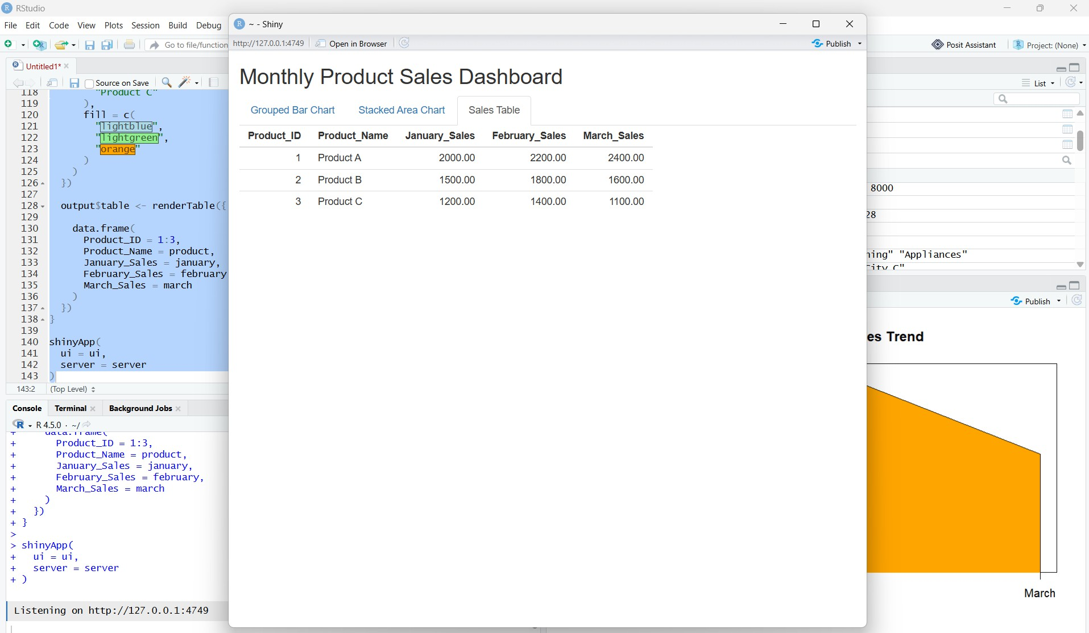
Output 4: Interactive Monthly Sales Dashboard

Observation: An interactive product sales dashboard containing the grouped bar chart, stacked area chart and monthly sales table was successfully developed using RStudio Shiny..

Procedure
- Create vectors for Product ID, Product Name, January Sales, February Sales, and March Sales.
- Use a grouped bar chart to compare the sales of each product during the first quarter.
- Create a stacked area chart using the monthly sales values to visualize the overall sales trend of all products.
- Create a data frame/table to display the monthly sales information for each product.
- Develop an interactive Shiny dashboard in RStudio combining the grouped bar chart, stacked area chart, and sales table.
- Run the programs in RStudio and observe the visualizations and sales trends.

Result:
The monthly product sales were successfully analyzed using different visualizations and an interactive dashboard, making it easy to compare products and understand their sales trends.

